Heading to Camp: Sunday Bus Pick-Up Locations
Please arrive at least 15 minutes before pick-up time. Buses will not wait for participants. Participants coming from the mainland must bring $40.00 to cover their return ferry trip. Buses will be supervised by YES Staff Members.
Kelowna - Capri Centre  1835 Gordon Drive, Kelowna, BC V1Y 3A4 - Meet outside the Dollarama | 8:30 AM
Merritt - Esso Gas Station  3683 De Wolf Way #6420, Merritt, BC V1K 1C4 | 10:15 AM
Abbotsford - Yale Secondary School  34620 Old Yale Rd, Abbotsford, BC V2S 7S6 - Meet in front parking lot | 12:30 PM
Vancouver - Pacific Central Station  1150 Station St, Vancouver – Meet inside the station at the central clock | 1:45 PM
Horseshoe Bay Ferry Terminal - Meet near Ticketing Building  Catching the 4:00 PM Ferry | 2:45 PM
Departure Bay Ferry Terminal  Foot Passenger Pick-up/Drop-off area | 5:45 PM
Arrive at Camp | 7:15 PM
Heading Home from Camp: Saturday Bus Drop-Off Locations
Leave Camp | 8:30 AM
Departure Bay Ferry Terminal  Catching the 10:55 AM Ferry | 9:40 AM
Horseshoe Bay Ferry Terminal | 12:30 PM
Vancouver - Pacific Central Station  Depending on traffic, the bus is sometimes delayed from this stop | 1:45 PM
Abbotsford - Yale Secondary School | 3:00 PM
Merritt - Esso Gas Station | 5:00 PM
Kelowna - Capri Centre | 6:30 PM
Drop Off & Pick Up By Car
Sunday (First Day of Camp)
Participants should be dropped off at the campsite at 7:00 PM
- Please do not arrive before 6:45 PM - the gate will be closed, and you will have to wait. The drive from Duncan is approximately 30 minutes.

Saturday (Last Day of Camp)
Participants should be picked up at the campsite at 8:30 AM
- Please be on time, as it is necessary to get participants home to all parts of the province

The Camp is held at the Cowichan Lake Outdoor Education Centre (CLEC). The CLEC is located one kilometre west of the town of Lake Cowichan and 96 km from both Victoria and Nanaimo. CLEC is 28 km west of Duncan. The site is at the end of Lakeview Park Road, contrary to Google Maps’ listing.

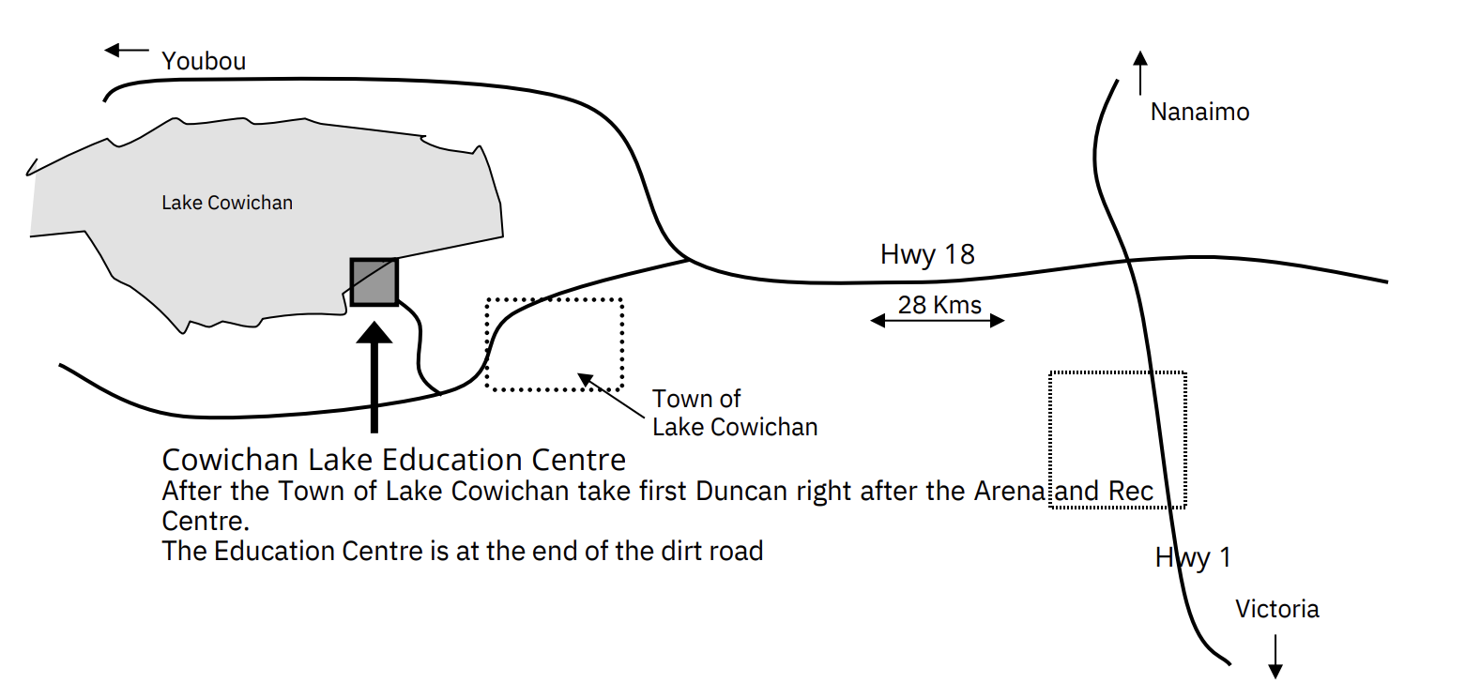

Important Snack & Meals Note:

An evening snack will be provided when participants arrive at camp. Please ensure that participants have enough food packed for lunch on the bus, a packed dinner or money to buy dinner on their ferry/transit journeys. Lunch will be provided on the return trip. Please ensure that all food is nut-free, as many participants have severe allergies.

If you have any questions or require clarification, please don’t hesitate to contact The YES at info@theyes.ca or call us at 604-960-1377.

Please Bring:
- Sleeping bag & pillow
- Hat, sunscreen and a reusable water bottle
- Pyjamas
- Toiletries: shampoo, toothbrush, toothpaste, deodorant, etc.
- Some warm clothes, sometimes it gets chilly
- Towel and swimsuit
- Runners and Sandals
- Nice clothes for the end-of-camp banquet
- Rain jacket
- A blank, 100% white cotton t-shirt for tie-dying, or $10 to purchase one if you didn’t already do so during registration.

Optional but useful items: flashlight, camera*, musical instrument*, alarm clock/watch (since you won’t have your phone), cash to purchase merchandise (hoodies, stickers, t-shirts), unscented hand sanitizer.

*Please note: bring valuable items such as instruments, cameras, etc., at your own risk. The YES cannot be held responsible for the loss or damage of these items.

Do Not Bring:
- Alcohol, non-prescribed drugs, or weapons. There is no tolerance for the possession of any of these items. Participants in possession of any of these will be sent home.
- Vaping devices will also not be permitted.
- Cellphones are permitted at camp but will be collected. The YES is a cellphone-free program. Participants will have access to a camp-provided phone should they need to contact home.
- Snacks with nuts. We commonly have severe nut allergies at camp, and we request that you bring no snacks with nuts or traces of nuts. There will be plenty of food provided during the week.

If you have any questions or require clarification, please don’t hesitate to contact The YES at info@theyes.ca or call us at 604-960-1377.

